RESOLUTION NO.__________

RE: CERTIFICATE OF APPROPRIATENESS UNDER THE
PROVISIONS OF THE ACT OF THE PENNSYLVANIA
LEGISLATURE 1961, JUNE 13, P.L. 282 (53
SECTION 8004) AND BETHLEHEM ORDINANCE NO.
3952 AS AMENDED.

WHEREAS, it is proposed to replace fence with a new cedar 6’-0” high fence at 24 E. Wall St.

NOW, THEREFORE, BE IT RESOLVED by the Council of the City of Bethlehem that a Certificate of Appropriateness is hereby granted for the proposal.

Sponsored by: (s)

(s)

ADOPTED BY COUNCIL THIS DAY OF

(s)
President of Council

ATTEST:

(s)
City Clerk

HISTORICAL & ARCHITECTURAL REVIEW BOARD

The applicant proposes to replace wooden fence at 24 E. Wall St.
APPLICATION #2:

Moravian Board of World Mission
P.O. Box 1245, 1021 Center St.
Bethlehem, PA 18016

OWNER:

__________________________________________________________________

The Board upon motion by Nancy Shelly and seconded by Gen Marcon adopted the proposal that City Council issue a Certificate of Appropriateness for the following:

- New fence to be 6’-0” high made of cedar with a simplified top.

- The new fence will receive a clear oil based sealer.

3. The motion was unanimously approved.

__________________________________________________________________________

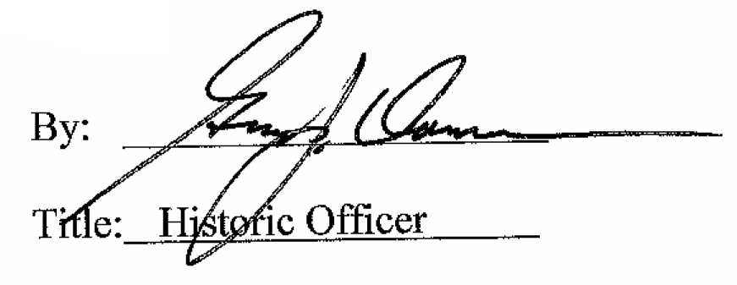

Date of Meeting: Octrober 7, 2015

